QUESTION 4

193079024

SARVESH KALE

**Q4 a.)**

We have to find the set of reachable states starting with 0,0

We first define the variables y,x1,x2,q0,q1 ,q0_,q1_ where q0_and q1_ are next state variables .

We first construct the characteristic equation X of the for below

X = xnor(q0_,xor(x1,x2,q1)) . xnor(q1_,xor(x2,q0))

And initial state

A= and(not(q0),not(q1))

We then multiply the two and perform there exist operation on x1,x2, of the following equation

Next state = (there exist x2(there exist x10(A.X)))

The above operation says that given the transition function and a set of intital states ,where will I be in next instant is given by q0_,q1_ so this is also a bdd .

Now the next state variables should be replaced by q0,q1 by changing the association and applying the substitute function ,so now the next state obtained becomes the present state and is accumulated to the set of reachable states R by adding this to the state R0 which is a set of all possible states till time 0,so

R1= R0 + present state .

We then again perform the same operation using a do while loop and the stopping condition is that R(k+1) = R(k) that is no new additions to the set of reachable states then stop the loop and report the values .

The output obtained is

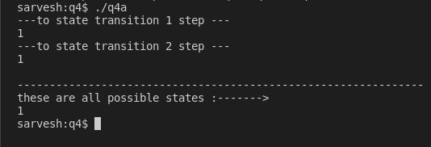

Here it says that after first transition, the set of all reachable states is 1 which is the entire universe of variables q0,q1 ,so all the states 00,01,10,11 are reachable ,

Since a do while loop is used ,the iteration stops on the second step because it is at this step that the R(k+1)=R(k) condition holds .

**4 b.)**

The CNF calculations are shown below

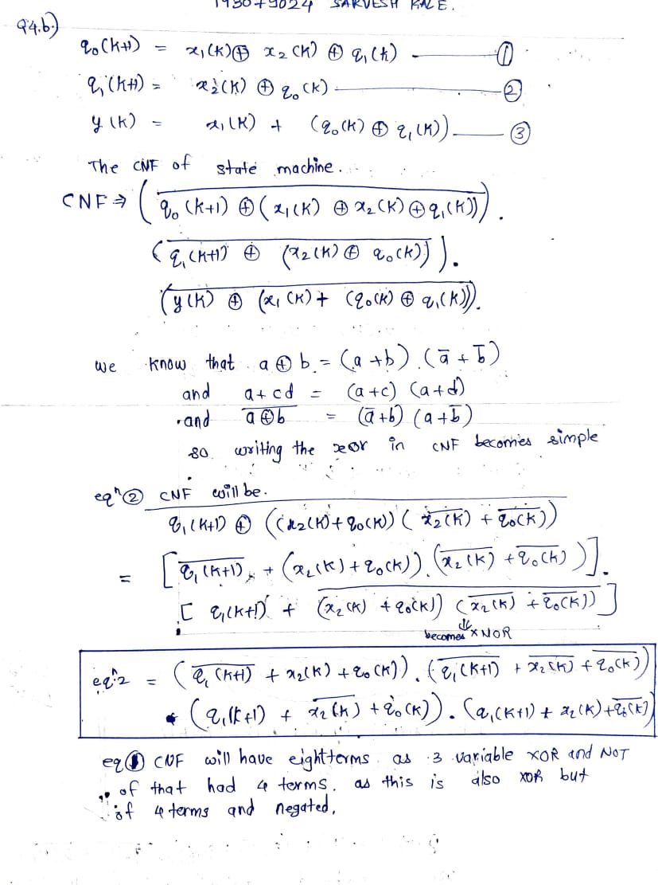

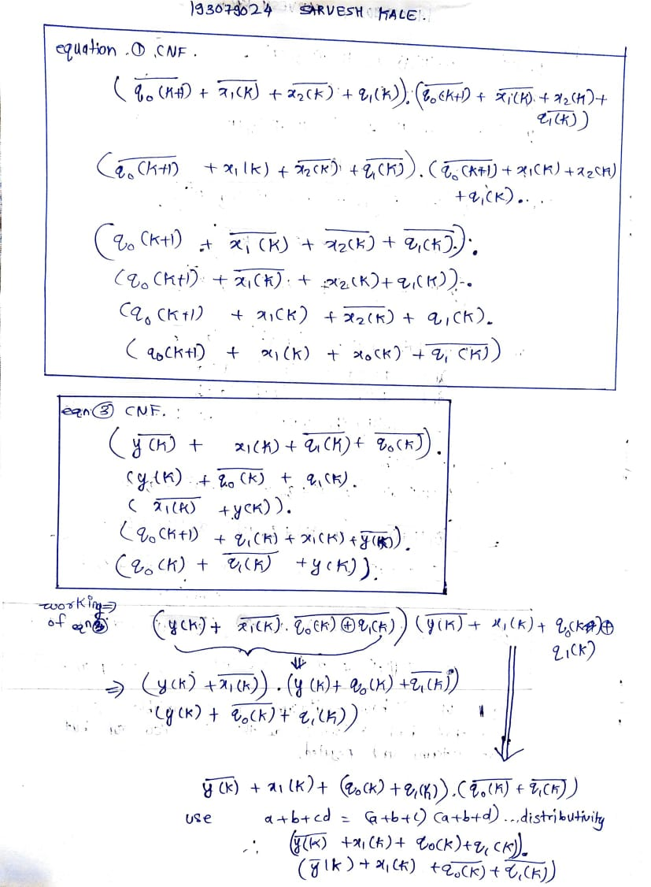

We have to check whether the FSM outputs the sequence 0 11 01 0 ,the way I have done is my inputs are 1 to 12 . 1,2 being inputs of FSM at time instant 0 . 3,4 being inputs to FSM at time instant 1 and so on .

13 ,14 are my states at time instant 0 and 15 is my output

16,17 are my states at time instant 1 and 18 is my output and so on

I consider 32 variables ,31 and 32 will be next states of time step 5 untill when the FSM has been simulated 6 times from 0 to 5 .

We can see a pattern in the way the inputs ,states and outputs have been chosen ,The CNF expressions re available to us ,so I wrote a C code to generate the patterns in DIMACS format which will be input to the SAT solver . After the pattern is generated by C file ,we copy paste the output from terminal to the CNF file and add additional 6 clauses ,these clauses are that output 15 should be 0 ,output 18 should be 1 ,output21 should be 1 ,output 24 should be 0 ,Output 27 should be 1 and output 30 should be 0 .

After we complete the CNF file we pass it to a SAT solver ,the following is our output .

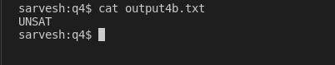

The UNSAT means that the sequence 011010 does not occur .